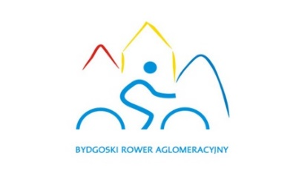 |  |  | COMPLAINT
 |  | bike User’s full name
 |  | BRA account Owner’s full name
 | login |  |  |  | phone number
 |  | address of residence
 | THE RENTAL – ACCORDING TO THE SYSTEM
 |  |  |  |  |  | fee
 | rental station |  |  |  | return station
 |  | date and time |  |  |  | date and time
 |  |  |  |  |  | duration
 | THE RENTAL – ACCORDING TO THE USER
 | rental station |  |  |  | return station
 |  | date and time |  |  |  | date and time
 |  | way of return* |  |  |  | duration
 | ADDITIONAL INFORMATION
HOW TO COMPLETE A COMPLAINT FORM:
- The form consists of 18 fields.
- The „THE RENTAL – ACCORDING TO THE SYSTEM” section should be completed in accordance with the rental details, which are included in the Personal Account in the BRA system.
- The „THE RENTAL – ACCORDING TO THE USER” section should be completed with the rental details according to the User’s knowledge.
- The „ADDITIONAL INFORMATION” section should be completed with the rental description.
- The completed form should be sent via e-mail to bok@bra.org.pl

* way of return: electrick lock / combination (flexible) lock

